* Skin on the finger contains friction ridges, has no hair, has no oil glands, and has lots of sweat pores.
* The pattern of ridges is believed to be unique and persistent, thus useful for person identification.
* Touching an object will leave a latent print on it, thus useful for solving crime.
* Fingerprint:
  + Description: graphical flow like ridges present in human fingers
  + Formation: during embryonic development
  + Permeance: minute details are believed to not change over time.
  + Uniqueness: believed to be unique to each finger
  + HIstory: used in forensics and has been extensively studied
* Fingerprint Formation:
  + Ridge formation starts at 1 or 2 focal point and spreads over the fingertip
  + Localized ridge units merge to form ridges at ~10.5 weeks estimated gestational age.
* Fingerprint Classification:
  + Assign fingerprints into one of the pre-specified types.
  + 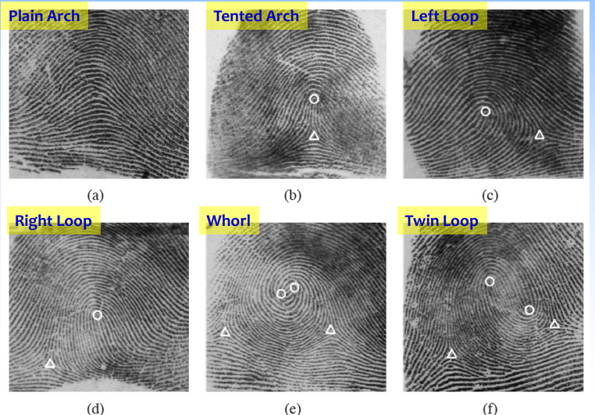
* Fingerprint Recognition:
  + Determine if two fingerprint images originate form the same finger or not
  + Use principles of object sensing, image processing, computer vision, and pattern recognition to automate the process
* Representative Applications:
  + FBI IAFIS : Law Enforcement 1-to-N
  + DHS OBIM : Border control 1-to-N and 1-to-1
  + iPhone Access Control: 1-to-1
* 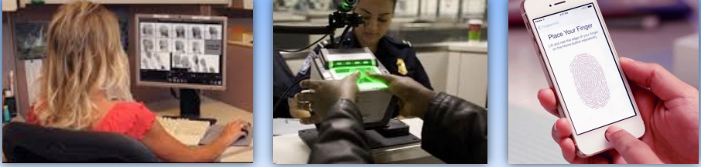
* Image Resolution
  + Increasing the resolution of the scanner reveals biometric details that can enhance the “uniqueness” of the trait.
  + However, this may lead to an increase in “noise”.
  + 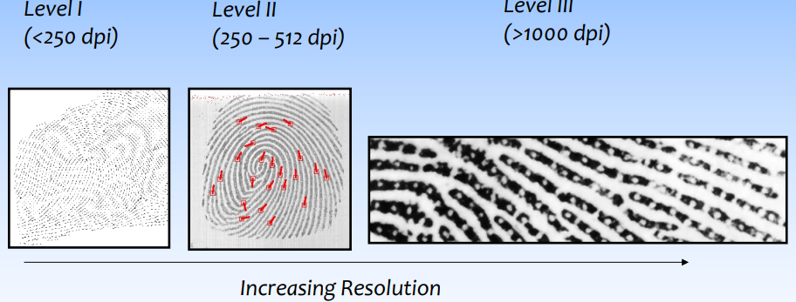
* Fingerprint Features:
  + A fingerprint can be described at 3 levels from coarse to fine. Coarse level representation can be derived from finer level representations.
  + Level 1: Ridge orientation nd frequency -> singular points (fingerprint classification)
  + Level 2 : Ridge skeletons -> minutiae points (fingerprint matching)
  + Level 3: Out and inner contours of ridges (more detailed fingerprint matching)
  + 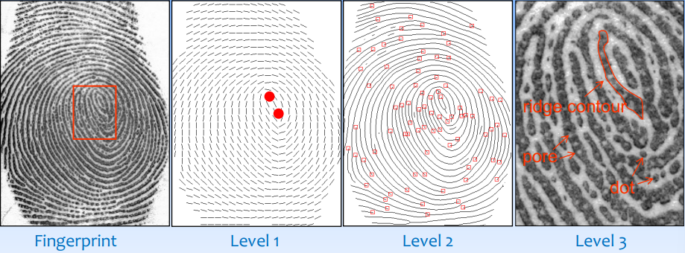
* 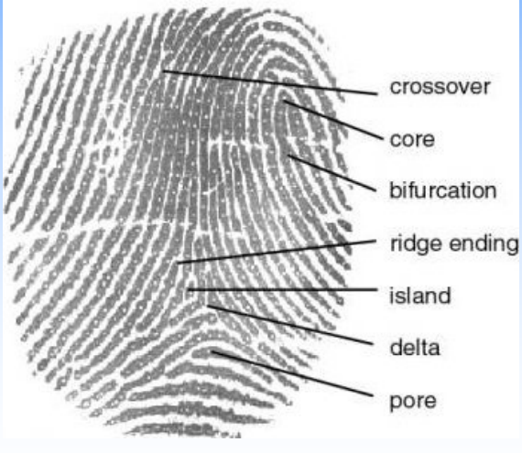
* Flab/Dab Fingerprint : One-touch print front a single-finger livescan device.
* Slap Fingerprint : 4-finger simultaneous impression from livescan devices or scanned from paper FP cards
* Rolled Fingerprint : image collected by rolling the finger across the livescan platen or paper from nail to nail.

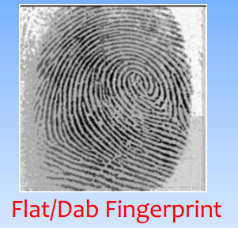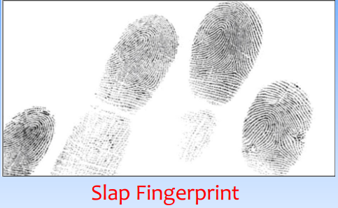

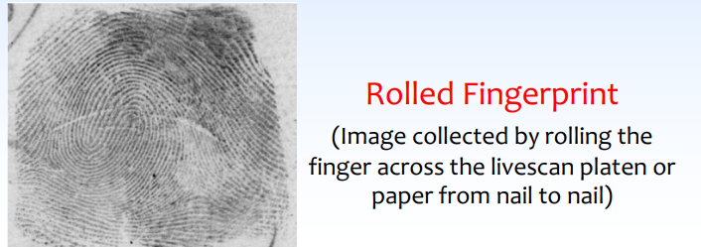

* Inking Method
  + Rolled fingerprints are larger in size, but distortion is large due to rolling.
  + Plain fingerprints are smaller in size, but distortion is smaller.
  + Plain fingerprints are also used to ensure correct order of rolled fingerprints.
  + Both rolled and plain fingerprints are captured in an attended mode, so quality is good and contained rich information.
  + They are called exemplar fingerprints.
* 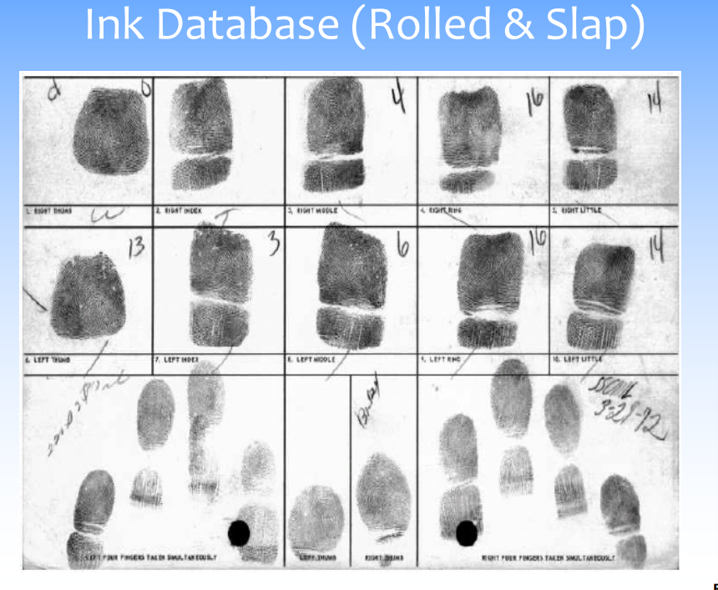
* Recording Latent Prints
* 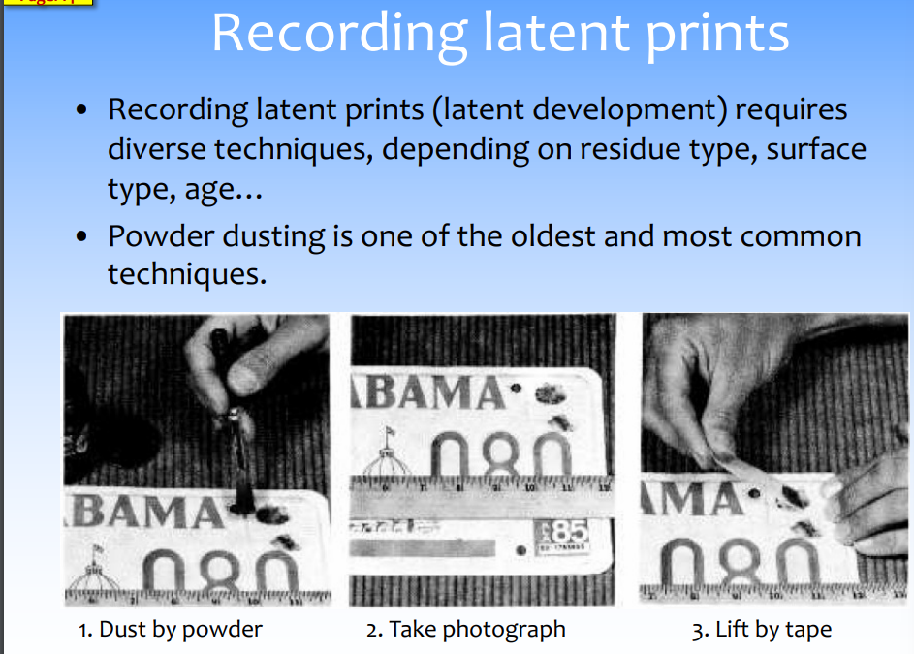
* Online Sensing Techniques
  + Many online fingerprint sensing techniques:
    - Optical Frustrated Total Internal Reflection (FTIR)
    - Capacitive
    - Ultrasonic
    - Thermal
    - Direct imaging
    - 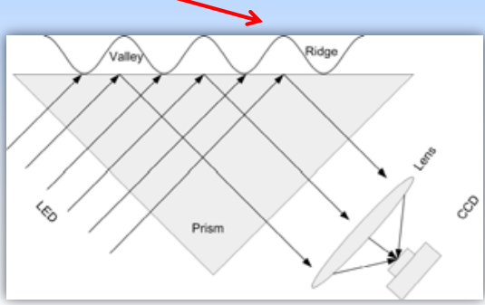
* Ridges absorb light (dark colored)
* Valleys reflect light (light colored)
* 